ISTW 2019 ROUEN, NORMANDY, FRANCE – ACCOMMODATION FOR ALL PARTICIPANTS FROM ABROAD
RESIDENCE NEXITY STUDEA
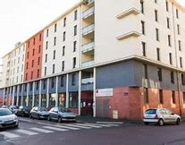 |  | 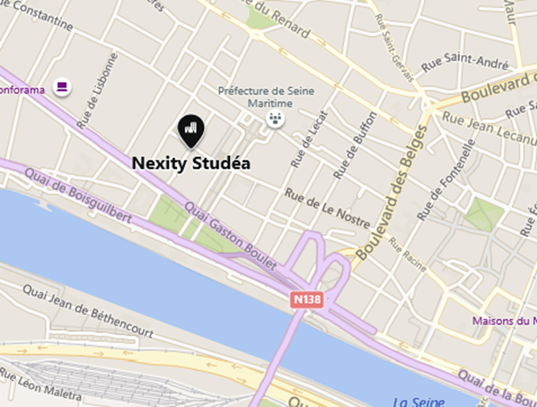
Address : 11, Rue Emile Leudet, 76000 Rouen Web : https://www.nexity-studea.com/locations-etudiantes/rouen/studea-rouen-prefecture-po0000230
Location : well located, in front of the Pasteur Campus of the University of Rouen Normandy (meeting point each day) and next to the old city center (10- minute walk – 5 min with the bus – bus station is around the corner). 3-minute walk from the ARMADA tall ship Festival.
Rates : 141 € for 3 nights (from Tuesday 4th to Friday 7th 2019)
IMPORTANT : no other possibility to stay in Rouen at a very affordable price . It will be ARMADA time !

