Fourth International Week
Marketing Department
University Institute of Technology
Angers 9th-12th May

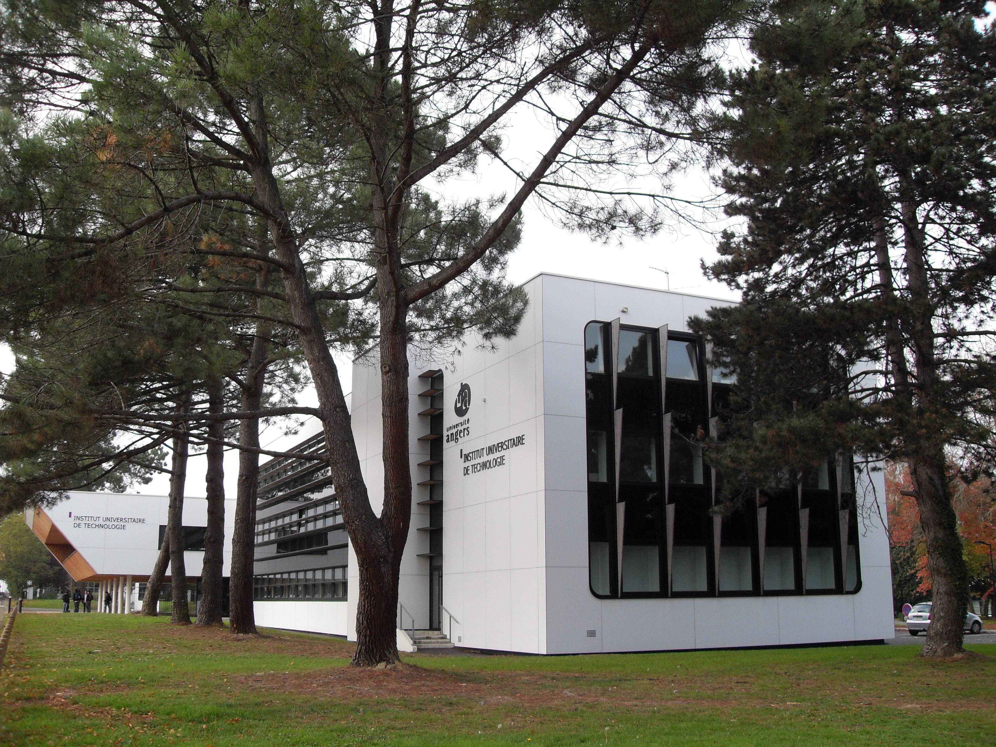
IUT Angers

It is our pleasure to invite you to the fourth edition of International Week, organized by the department of Marketing of the University Institute of Technology of Angers from the 9th to the 12th of May 2017.

The event is designed to raise an intercultural awareness among students through the creation of an international learning environment. It also aims to strengthen our international networks by exchanging with the representatives of our partner universities in an extra-curricular context. This week will also be open to non-partner universities willing to contribute to our activities.

The International Week will take the form of a series of lectures, seminars and workshops, and events conducted by our guests. As regards to the content, intercultural topics as well as topics related to the fields of marketing and management will be welcome. Participants can cover topics related to their field of expertise or to a particular aspect of the social, economic and cultural life of their country. Topics in previous editions included tourism in Ireland, the Scottish referendum, e-marketing in Portugal, traditional German food festivals, e-activism, adapting multinational’s advertising campaigns, American cultural icons, communication in the digital age, Spanish olive oil markets, marketing yoga and the economic crisis in Spain.

The International Week is targeted at first-year tertiary students. Our main goal is to familiarize students with the teaching methods of our partner universities and to encourage them to study abroad within their degree program. Therefore, we do not expect the material covered to be highly technical or in-depth. Interactive activities and workshops are most welcome.

Participants will be asked to give lectures, seminars, workshops or tutorials on subjects of their choice but with an intercultural perspective. The students will then be challenged to present projects related to the participant’s presentations using their skills in marketing and new technologies.

A Study Abroad Fair will be held to help promote student exchanges to our guests’ home institutions. In addition, a session will be held with the participants to discuss the possibility for joint projects, and distance teaching opportunities.

If you intend to come with some of your students, please let us know their number so that we can arrange for their accommodation on the campus and their program during the week.

It is anticipated that your home institution will meet travel expenses and additional hotel nights from its Erasmus Teaching mobility budget.

The University Institute of Technology of Angers will provide lunches and a welcome dinner. You will be invited to a guided tour of the Cointreau distillery production site and bar for a unique tasting experience. A financial contribution will be required for the excursion and lunch organized in a Troglodyte village near Angers.

If this proposal is of interest, please can you confirm by March ^{21st}.
a) the name(s) and email address(es) of participants
b) the proposed topics for their lectures and/or seminars;
c) the language of teaching if other than English.

We therefore look forward to hearing from you very soon.

Please send your answers to karima.thomas@univ-angers.fr

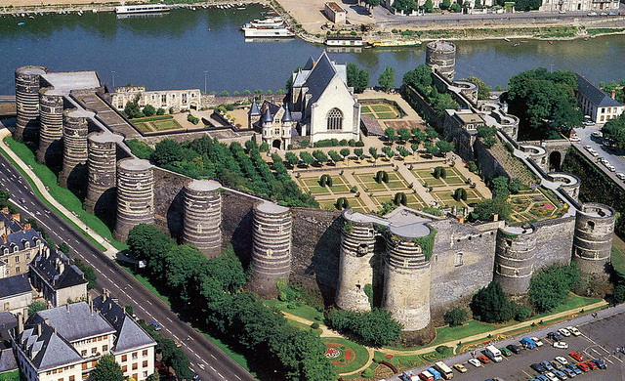Château d’Angers

Provisional Planning
Day 1 | time
 | 9:30-11 :00 | Presenting the participants. Coffee break
 | 11:00-12:30 | Plenary Lectures
 | 12:30-14:00 | Lunch
 | 14:00-15:30 | Seminars and workshops
 | 15:30-17:00 | Seminars and workshops

Welcome Dinner

Day2 | Time
 | 9:30-11:00 | Seminars and workshops
 | 11:00-12:30 | Plenary Lecture
 | 12:00-14:00 | Lunch
 | 14:00-15:30 | Seminars and workshops
 | 15:30-18:00 | Visiting Cointreau Distillery: guided tour of the production site and the distellery+tasting expeience

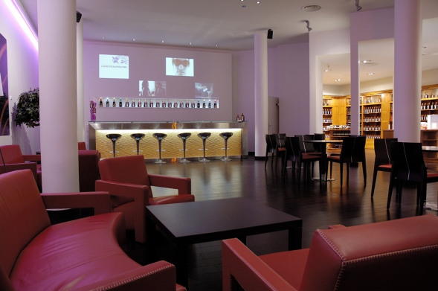Cointreau Distillery

Day 3 | Time
 | 8:00- 9:20 | Seminars and workshops
 | 9:20- 9:40 | Coffee break
 | 9:40-11:00 | Seminars and workshops
 | 11:00-12:30 | Seminars and workshops
 | 12:00-17h | Lunch and Excursion

Day 4 | Time
 | 9:30-11:00 | Tutorials
 | 11:00–12:30 | Study abroad fair
 | 12:00:14:00 | Lunch
 | 14:00-16:30 | Students’ presentations

