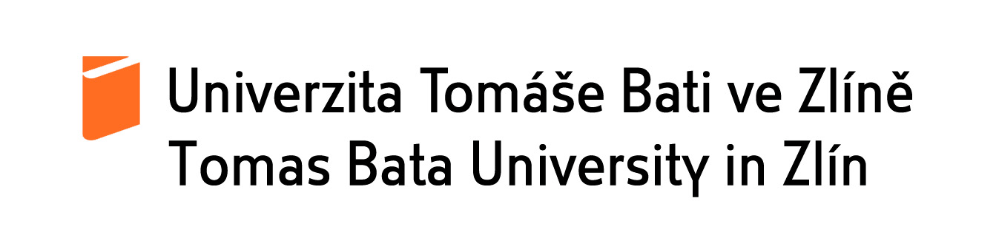

**INTERNATIONAL WEEK2019**

**PRELIMINARY AGENDA**

8 April – 12 April 2019

**SUNDAY, 7. 4. 2019**

Arrival and check-in

**MONDAY, 8. 4. 2019**

Arrival and check-in

Welcome presentation on Tomas Bata University

Lunch

Sessions

Welcome dinner with Tomas Bata University representatives

**TUESDAY, 9. 4. 2019**

Sessions

Lunch

Sessions

**WEDNESDAY, 10. 4. 2019**

International Festival – promotion of study abroad opportunities to TBU students

Lunch

Guided Tour

**THURSDAY, 11. 4. 2019**

Guided tour (whole day)

**FRIDAY, 12. 4. 2019**

Session and departure