|  |  |  |
| --- | --- | --- |
|  | **ROMANIA**MINISTRY OF NATIONAL EDUCATION„Gheorghe Asachi” Technical University of IaşiBulevardul Prof. Dimitrie Mangeron nr. 67, 700050 – IAȘI **Telephone and Fax +**40 232 278628 URL: www.tuiasi.ro E-mail: international@tuiasi.roVICERECORATE FORINTERNATIONAL RELATIONS |  |

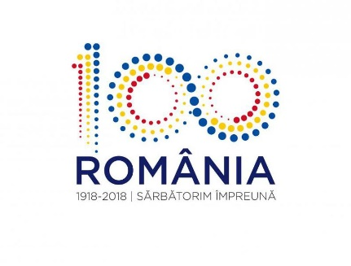

*_________________________________________________________*

Dear Colleagues,

”Gheorghe Asachi” Technical University of Iași (TUIASI), Romania, is organizing its 2nd Erasmus Staff Training Week from **8 to 12 of October 2018 in Iași, Romania**.

Embedding Internationalization in universities is nowadays of paramount relevance in everything we do. Communication and sharing the necessary information between partners is vital and hence its translation in accessible digital format becomes natural and challenging at the same time.  
  
We invite you to join our event, ***Framing International in Digital Format***, and actively share your opinions and good practices.

The main topics are:

* Digital tools in internationalization – tools examples, how we use them to optimize the internationalization of university;
* Erasmus+ application – on-line app development;
* Good practices in digital internationalization;
* Digital resources for students.

Online applications are available on the following link, <http://intstw.tuiasi.ro/#home>, where you will find the Registration Form.

Please, note that we are also on IMOTION page: <http://staffmobility.eu/staffweek/framing-international-digital-format>

Some thoughts about the first edition you can find on <http://www.international.tuiasi.ro/events/international-staff-week>

For any other information you might need, please do not hesitate to contact us at [international@tuiasi.ro](mailto:international@tuiasi.ro).

We look forward to welcoming you at TUIASI and enjoying both our programme and wonderful city at the same time!

*TUIASI International Relations Team*