**Korean Language Education Center**

**Korean Language Education Center (KLEC)**

Sogang Korean Language Education Center (KLEC) is a professional Korean Language Education Center that was established in 1990 with the goal to popularize and spread the Korean language and Korean culture throughout the world.   
Since its establishment, over 30,000 students from overseas have learned about Korean culture and language by participating in our program. Currently, average of 3,500 students register for the Korean Language Education Center every year.

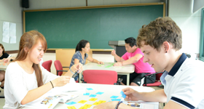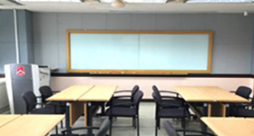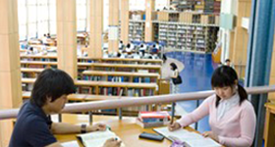

**Program Features and Advantages**

**Education focused on speaking**

Unlike other Korean language centers, the courses at KLEC focus on practical speaking skills rather than grammar. More than 2 out of 4 hours of class instruction is concentrated on speaking activities.  
Since the courses are focused to improve on the speaking ability, the educational system provides essential skills for those students who need to adjust to Korea in a short amount of time or those who have to interact with a lot of people.  
Currently, the textbook series for our Korean Language Program, which were developed within our center, focuses on speaking which consists of approximately 57 volumes from levels 1 through 6 (including grammar and vocabulary references for many languages). Additionally, a guidebook for instructors will be published soon as well. We are also developing a number of supplementary textbooks to be used with this series. Our instructors incorporate a variety of audio-visual materials that bring authentic and real-life scenarios to the classroom. We keep our materials current by continuously updating them on a yearly basis.

**Education focused on the learners**

We believe that it is essential for the instructors to implement classroom techniques towards the learners. As a result, during class time our instructors play the role as the assistants to help each students to learn to articulate their opinions.  
Since the establishment of our student-centered curriculum, we have done our best to reflect and accommodate the requests and interests of our students to create an engaging learning environment.  
It is our goal to develop and offer courses that match all the special interests or goals our learners have. For example, learning Korean through songs, Chinese characters, and so on.

**Outstanding Instructors**

The faculties at Sogang University Korean Language Education Center consists of 7 full-time instructors and 60 full-time contract instructors. Since all instructors at Sogang KLEC are employed from the beginning as regular and full-time faculties, they maintain a high level of enthusiasm and sense of responsibility. All of our instructors boast outstanding achievements in both Korean language and Korean studies fields. Also they share their research results and teaching methods during our workshops and meetings that are held frequently.  
Additionally, we have established a homeroom teacher system where each homeroom teacher keeps track of their students’ attendance and test results and provide consultations when needed. Each instructor has their own office so that they can consult the students who are assigned to them. This system allows the instructors to provide learners with expert advices regarding any difficulties they may encounter when learning Korean language or living in Korea.

※ Regarding admission requirements, schedule, courses offered, please contact below.

**Contact Information**

* icon cursor

<https://klec.sogang.ac.kr/>

* icon mail

[ckss@sogang.ac.kr](mailto:lovesogang@sogang.ac.kr)