**Sogang Korean Studies Summer Program**

**Sogang Korean Studies Summer Program**

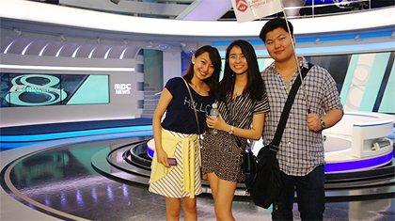Sogang Korean Studies Summer Program is a 5 week-long program that combines Korean Studies Seminars taught in English (by Korean and international faculties) and intensive Korean language instruction. The Korean language program is worth 3 credit hours and the Korean Studies academic courses worth maximum of 6 credit hours. Therefore, students can take maximum of 9 credit hours, or minimum of 6 credit hours.  
The Korean language course in the Korean Studies program will be offered by the Korean Language Education Center, which is renowned for challenging learners to communicate in Korean from the beginning. And the academic courses are offered in English by Sogang University and international faculties.  
Field trips are held every Friday and it is part of the Korean Studies Seminars. Students will go on a field trip to fascinating places such as the National Museum of Korea, Changdeok Palace, MBC Studios, Korean Film Archive and DMZ. In addition to the field trips on Fridays, international students will be able to experience more of Korea (including Nanta performances) by spending time with Sogang University students through our buddy program.

**Special Features**

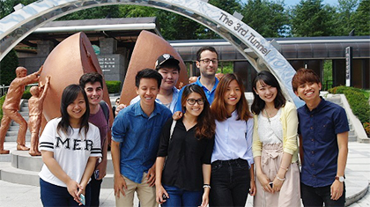

**Focused on Korean Studies** Diverse courses focus on Korean Studies including literature, music, architecture, language, culture, politics and Hallyu (Korean Wave).  
**Interesting cultural programs** Unique experiences with field trips every week to historical and cultural locations.  
**High quality of Korean Language Education** Provide world-renowned language programs with combined skills of thinking and performing to communicate better in Korean.

**Contact Information**

* icon cursor

[http://summer.sogang.ac.kr](http://summer.sogang.ac.kr/)

* icon mail

[summer@sogang.ac.kr](mailto:lovesogang@sogang.ac.kr)