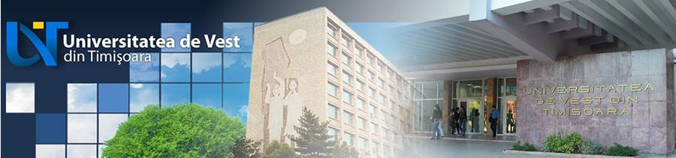
Erasmus Staff Training Week 5th
edition 2018
23rd – 27th April


DEPARTMENT OF INTERNATIONAL RELATIONS
B-dul Vasile Pârvan, Nr. 4, 300223 Timişoara, România
Tel. (Fax): +4 0256-592.352 (313), E-mail: international@e-uvt.ro www.ri.uvt.ro.
.

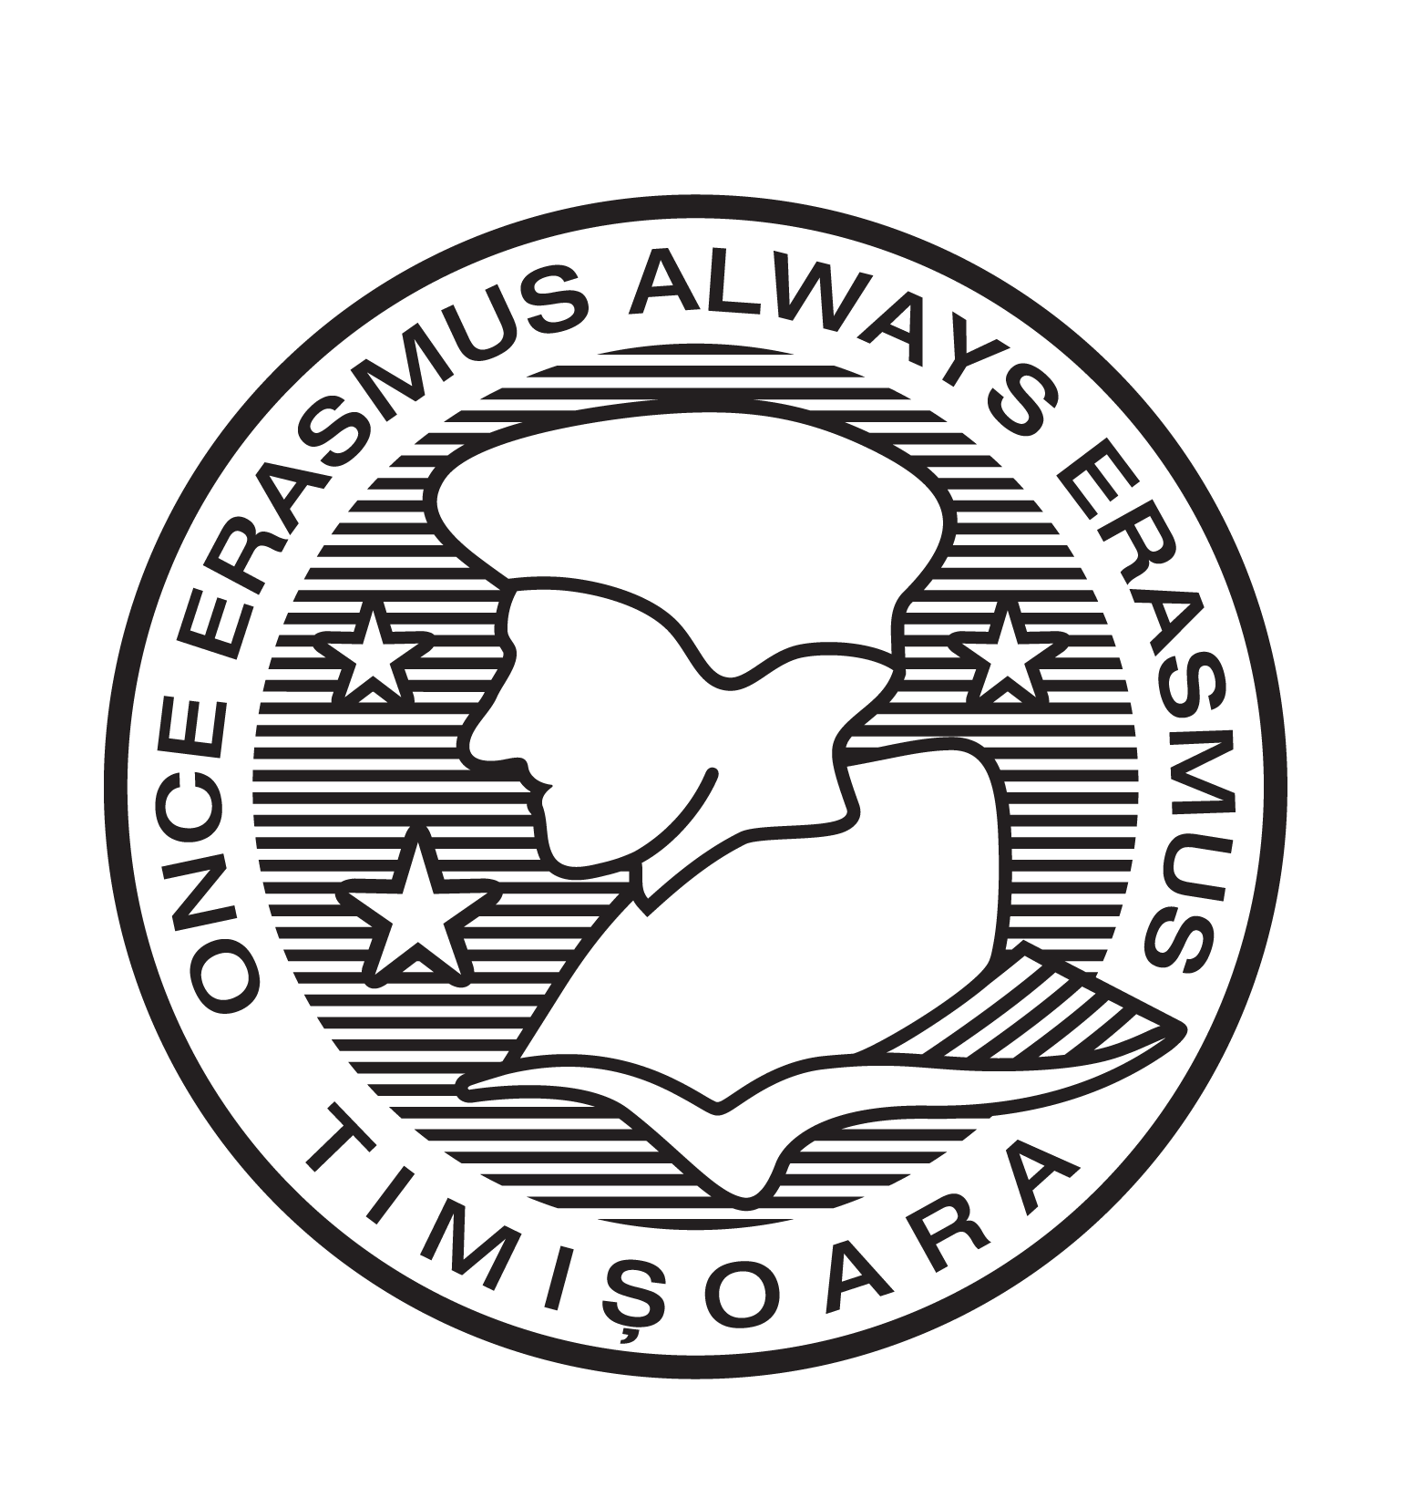

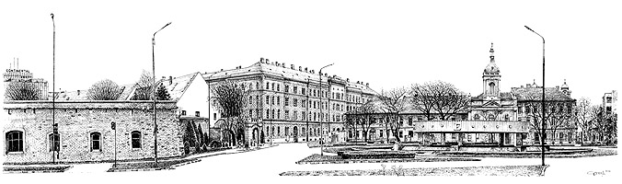


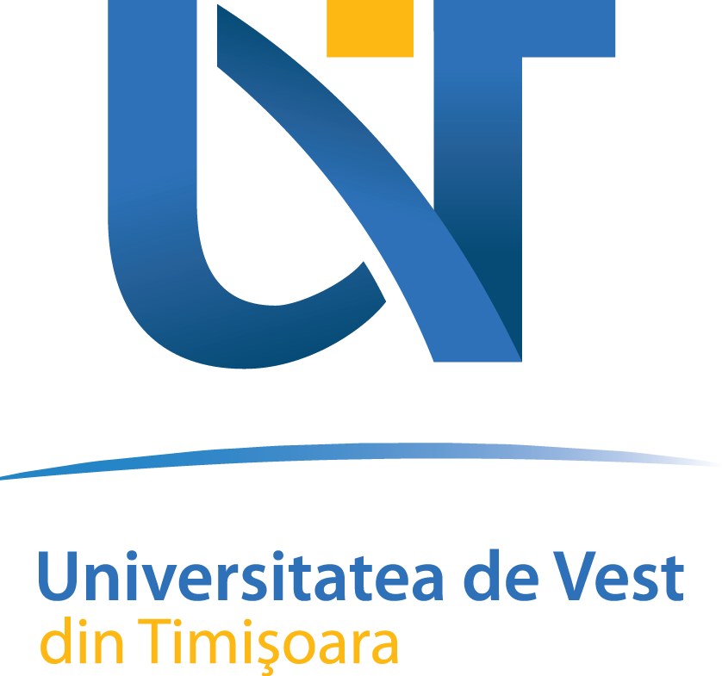
E r a s m u s S t a f f T r a i n i n g W e e k RO TIMISOA01 2 3rd - 2 7 t h A p r i l 2 0 1 8
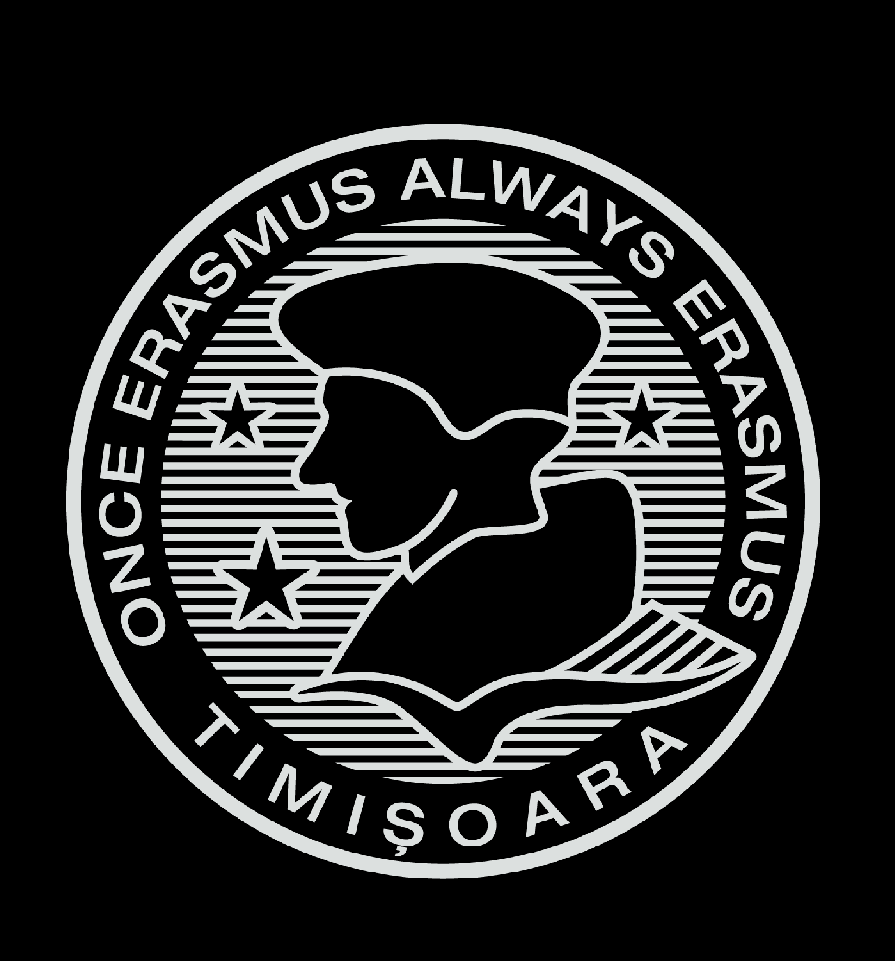  Monday, 23rd of April 2018 |  | 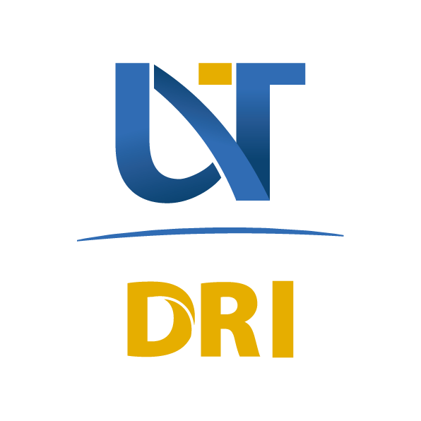
 | Registration and Welcome Meeting
 | Campus tour
 | Networking Dinner – Romanian traditional food
Tuesday, 24th of April 2018
 | Presentation of participant universities - Day 1
 | Romanian language crash course
 | Banat Village Museum
Wednesday, 25th of April 2018
 | Presentation of participant universities - Day 2
 | Job shadowing - Day 1
 | Museum of Revolution/ Contemporary Arts
Thursday, 26th of April 2018
 | International credit mobility programme: WUT’s experience
 | Job shadowing - Day 2
 | Farewell Dinner - Trip to Vineyard Recas
Friday, 27th of April 2018
 | Evaluation/ Conclusions
 | Handing out documents

